

**WEBSITE**

**N TOURISM**

**GROUP MEMBERS:**

**Amogha Varshini**

**Neha Priya R**

**Kavya J D**

**Vidya P B**



INTRODUCTION

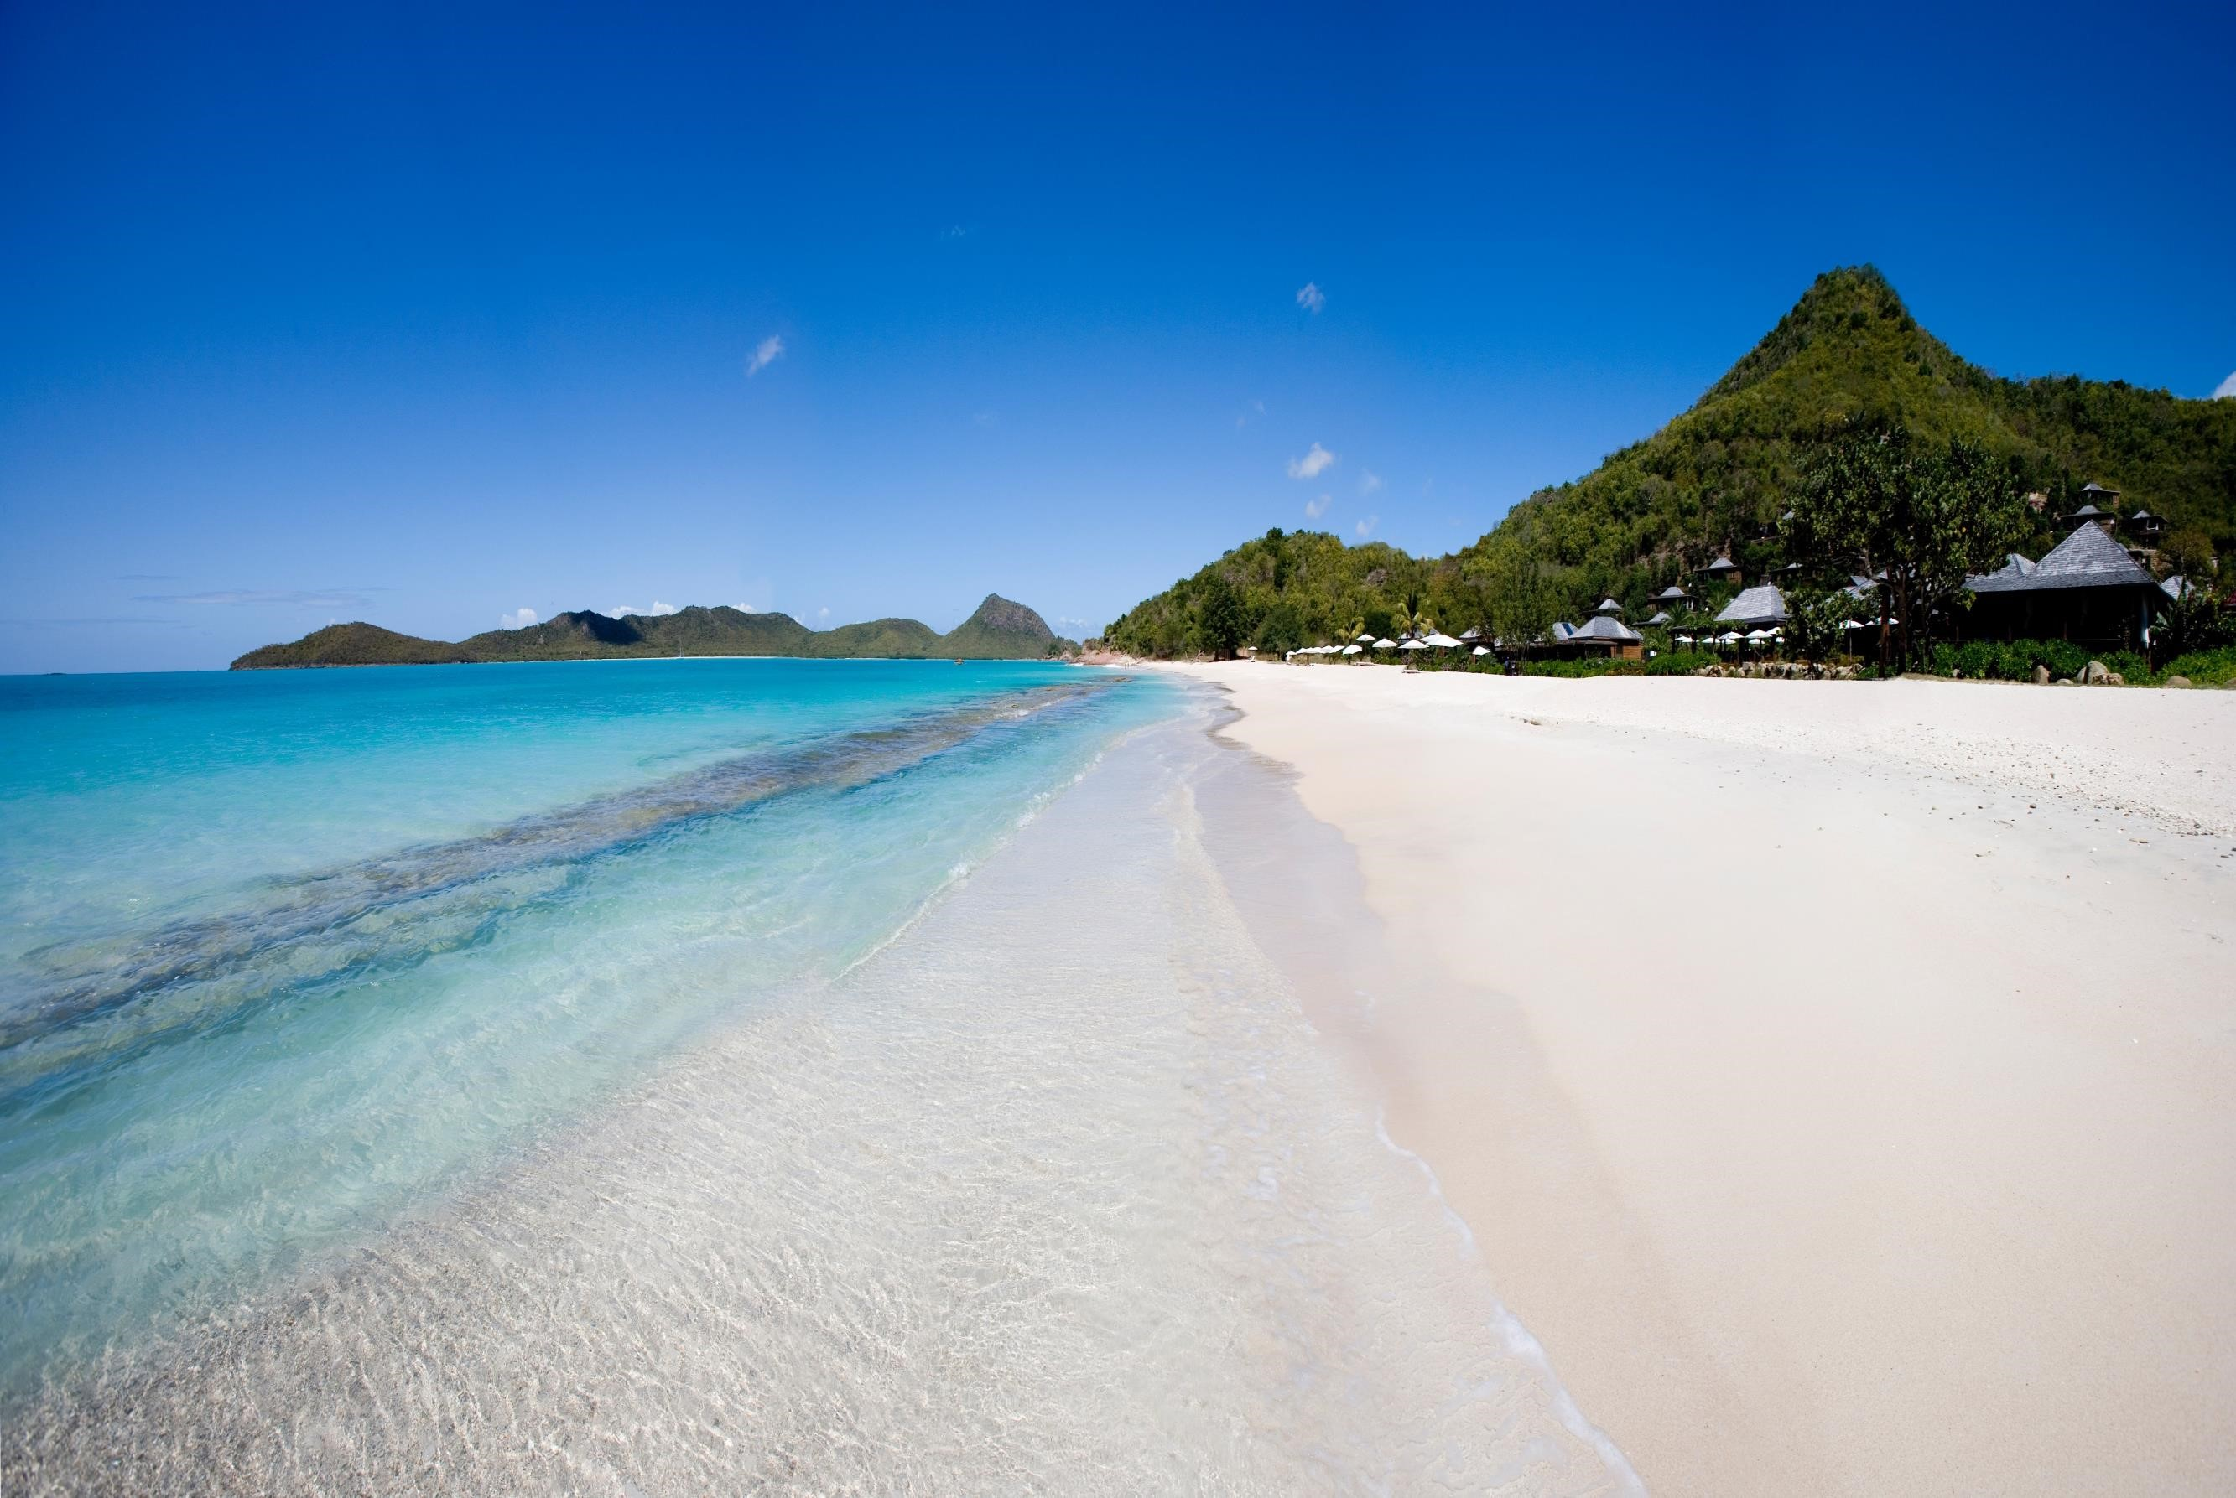A tourism website serves as a virtual gateway to a destination, enticing potential visitors to explore and experience its unique offerings. - It showcases attractions, landmarks, activities, and local culture through captivating visuals and engaging content. - Whether you're planning a vacation or seeking inspiration, a well-designed tourism website provides valuable insights.



**Diverse Audience**

:

Catering to various traveler types

—

adventurers, families, luxury seekers

—

requires tailoring content

and services.

**Information Overload**

:

Balancing comprehensive details without

overwhelming users can be challenging.

**Mobile Responsiveness**

:

Ensuring seamless browsing across

devices is crucial in today's mobile

-

centric world.

**Problem Scoping**

**PURPOSE OF**

**THE WEBSITE**

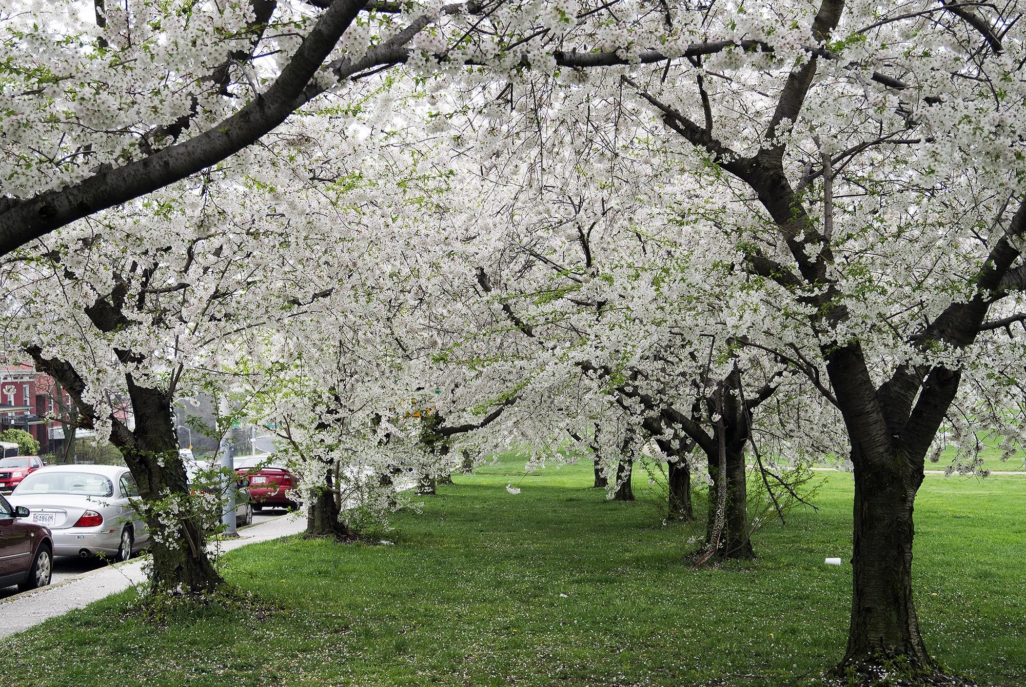

**PURPOSE OF THE WEBSITE**

Information Hub: Provide comprehensive details on

destinations, attractions, accommodations, and

activities.

Trip Planning: Facilitate trip planning by offering

itineraries, weather forecasts, and booking

options.

Community Building: Create a platform for

travelers to share experiences, tips, and reviews

# FEATURES

Smart Booking Process: Set up an intuitive booking system with varied payment options and unlimited trip packages.

Informative Destination Pages: Include detailed information about each location, highlighting its unique aspects.

Social Media Integration: Connect with travelers and build a community around your website

# TYPES OF TOURISM

Leisure Tourism: Traveling for relaxation and enjoyment.

Business Tourism: Traveling for work-related activities.

Cultural Tourism: Exploring different cultures and traditions.

Adventure Tourism: Engaging in adventurous activities like hiking, diving, and safaris.

Eco-Tourism: Traveling with a focus on sustainability and natural preservation.